**GRATING LIGHT VALVE DISPLAY TECHNOLOGY**

**MOHAMMED ADAMU**

**(ST/CS/ND/20/314)**

**A SEMINAR REPRESENTED TO THE DEPARTMENT OF COMPUTER SCIENCE, SCHOOL OF SCIENCE AND TECHNOLOGY, FEDERAL POLYTECHNIC MUBI, ADAMAWA STATE, NIGERIA**

**NOVEMBER, 2022**

**GRATING LIGHT VALVE DISPLAY TECHNOLOGY**

**MOHAMMED ADAMU**

**(ST/CS/ND/20/314)**

**A SEMINAR REPRESENTED TO THE DEPARTMENT OF COMPUTER SCIENCE, SCHOOL OF SCIENCE AND TECHNOLOGY, FEDERAL POLYTECHNIC MUBI, ADAMAWA STATE, NIGERIA**

**IN PARTIAL FULFILLMENT OF THE REQUIREMENTS FOR THE AWARD OF NATIONAL DIPLOMA (ND) IN COMPUTER SCIENCE**

**NOVEMBER, 2022**

**Abstract**

*The grating light valve (GLV) technology is a micromechanical phase grating. By providing controlled diffraction of incident light, a GLV device will produce bright or dark pixels in a display system. With pulse width modulation, a GLV device will produce precise gray-scale or color variations. Built using micro electromechanical system technology, and designed to be manufactured using mainstream IC fabrication technology, the GLV device can be made both small and inexpensively. A variety of display systems can be built using GLV technology each benefiting form the high contrast ratio, fill ratio, and brightness of this technology. In addition, GLV technology can provide high resolution, low power consumption, and digital gray-scale and color reproduction*

**Keywords**: Light valves, Grating Light Valve (GLV), micro electromechanical systems (MEMS), Silicon Light Machines.

**Introduction**

The Grating Light Valve technology is a means for manufacturing high-performance spatial light modulators on the surface of a silicon chip. Inherent attributes of the GLV technology make it suitable for a wide variety of imaging applications, ranging from convention hall projection systems to consumer TV and workstation displays. The technology is based on simple optical principles that leverage the wavelike behavior of light by varying interference to control the intensity of light diffracted from each GLV pixel. A GLV array is fabricated using conventional CMOS materials and equipment, adopting techniques from the emerging field of Micro-Electromechanical Systems (MEMS). Pixels are comprised of a series of identical mechanical structures, fabricated using very few masks and processing steps. The end result is a unique combination of high performance, reliability, and low cost at production volumes (Bloom, 2007).

A typical GLV pixel is comprised of an even number of parallel beams, or “ribbons,” supported at each end. While pixel dimensions are scaleable, a typical design for a 25 µm pixel (as illustrated in Figure 1) might include six ribbons, each about 3 µm wide, 100 µm long, but only about 125 nm thick. These ribbons are suspended above a thin air gap (typically about 650 nm), allowing them to move vertically relative to the underlying surface. The ribbons are held in tension so that, when not deflected by electrostatic forces, they form a flat surface between the two opposite sets of anchor posts. The ribbons are made of silicon nitride, a ceramic material chosen for its high tensile strength and durability. The ribbons are overcoated with a thin layer of aluminum that functions as both an optical reflector and an electrical conductor (David *et al.,* 2009).

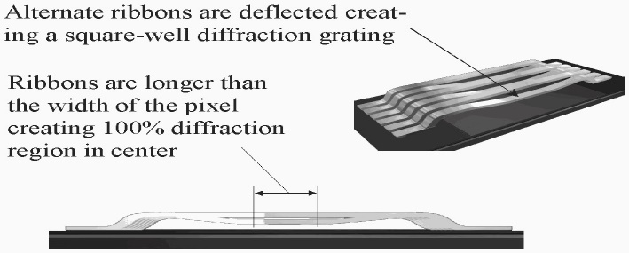

Figure 1: A Single, Addressed GLV Pixel (vertical scale exaggerated) (David *et al.,* 2009).

**Literature Review**

To address a pixel, a potential difference is applied between the alternate ribbon aluminum layers and the conductive layer in the underlying substrate. This potential difference creates an electrostatic attraction that deflects every other pixel ribbon downward toward the substrate, and thereby creates a square-well diffraction grating. Precise control of the vertical displacement of the ribbon can be achieved by balancing this electrostatic attraction against the ribbon restoring force; more drive voltage produces more ribbon deflection (Jahja et al., 2014).

Because the electrostatic attraction is inversely proportional to the square of the distance between the conductors, and also because the distances involved are quite small, very strong attractive forces and accelerations can be achieved. These are counter-balanced by a very strong tensile restoring force designed into the ribbons. The net result is a robust, highly uniform and repeatable mechanical system. The combination of low ribbon mass, small excursions (about 1/800 of the ribbon length), and large attracting and restoring forces produces extremely fast switching speeds. GLV pixel switching times have been measured down to 20 nsec three orders of magnitude faster than any other spatial light modulator we have seen reported (Jahja et al., 2014).

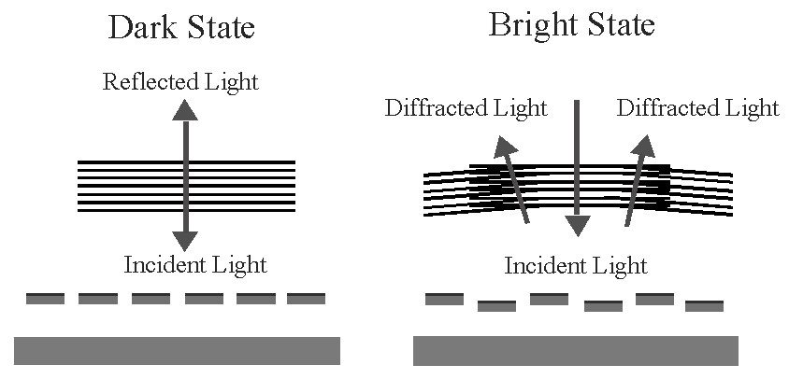

Figure 2: Reflective and Diffractive GLV Pixel States (Jahja et al., 2014).

### Optical Principles of the GLV Technology

When a pixel is not addressed, the undeflected ribbon surfaces collectively form a flat mirror that reflects incident light directly back to the source, as shown to the left of Figure 2. When a GLV pixel is addressed, alternate ribbons deflect downward creating a square-well diffraction grating, as shown to the right in the same figure. Varying the applied drive voltage—and thus the grating depth at each pixel controls the proportion of light that is either reflected back directly to the source or diffracted (Jahja *et al.,* 2014).

GLV devices can be operated in either digital or analog modes, enabling great flexibility in system design and product optimization. Digital operation capitalizes on the GLV technology’s tremendous switching speed to achieve shades of gray by alternately switching pixels fully “on” and fully “off” faster than the human eye can perceive. Very accurate grayscale levels are obtained by controlling the proportion of time pixels are on and off. In analog mode, video drivers precisely control the amount of GLV ribbon deflection; pixels are fully “off” when not deflected, and fully “on” when deflected downward exactly one-quarter the wavelength of the incident light. Deflecting GLV ribbons between these two positions creates variable grayscale intensity (Kim et al., 2004).

A Schlieren optical system is used to discriminate between reflected and diffracted light. By blocking reflected light and collecting diffracted light, very high contrast ratios can be achieved. We have measured the contrast of our GLV device at up to 1,000:1 (the sensitivity of our instruments). GLV devices are efficient light modulators. In an ideal square-well diffraction grating, 81% of the diffracted light energy is directed into the +/- 1st orders. By adding multiple Schlieren stops and collecting more orders, quite practical systems can achieve greater than 90% diffraction efficiency. Also, GLV ribbons are closely spaced and employ a highly reflective aluminum coating. For example, the device efficiency of a simple (+/- 1st orders only) GLV system, fabricated using 0.6 µm design rules, is the product of diffraction efficiency (81%), ribbon/gap efficiency (95%) and aluminum reflectivity (91%), or about 70% overall (Kenneth *et al.,* 2017).

### The Scanned GLV Array Architecture

Silicon Light Machines has recently demonstrated Bloom (2007), a high-performance front projection display system embodying an entirely novel system approach, which we refer to as the Scanned GLV Architecture.

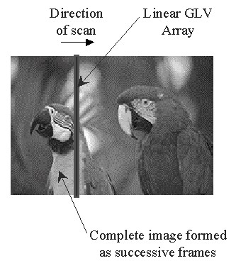

Figure 3: The Scanned GLV Architecture (Bloom, 2007).

In the Scanned GLV Architecture, a linear array of GLV pixels is used to project a single column of image data (see Figure 3). This column is optically scanned at a high rate across a projection screen. As the scan moves horizontally, GLV pixels change states to represent successive columns of video data, forming one complete image per scan. The high inherent switching speed of GLV devices makes a scanned linear architecture, and its many benefits, possible. For example, to create a 1,920 x 1,080-HDTV image with a 100 Hz refresh rate, each column of video data is displayed in stasis for about 4.2 µs (assuming a 20% flyback time); this requires a pixel switching time significantly less than 4.2 µs (David *et al.,* 2009).

The Scanned GLV Architecture gives Silicon Light Machines an enormous advantage in terms of modulator cost. To create a 1,920 x 1,080-pixel HDTV image using the Scanned GLV architecture, for example, we need to manufacture, interconnect, and address only a single linear array of 1,080 pixels; other spatial light modulator technologies would have to manufacture (with acceptable yields), interconnect, and address more than 2 million pixels (Timothy *et al*., 2013).

In addition to cost, the Scanned GLV Architecture provides a large number of other advantages when compared to current and emerging technologies. While a technical discussion of these advantages is outside the scope of this paper, a partial list includes: (1) high production yields; (2) smaller optics, (3) easy scalability to higher resolutions, (4) the ability of a single array to display different aspect ratios, (5) because of the small pixel count, the ability to fine-tune array uniformity after production, (6) because of the scanned linear array architecture, the ability to project line-sequential color with no color break-up, (7) because of the linear array geometry, optimal coupling to low-cost bar laser light sources, and (8) because of the small fraction of the die area occupied by the GLV array, straightforward integration of drivers and electronics on the same die without compromising optical performance (Perumal *et al.,* 2013).

# GLV Device Reliability

The Grating Light Valve technology’s simple mechanical and electrical design is intrinsically reliable. The ribbons (the only moving mechanical elements), are made of silicon nitride, a hard, dense ceramic material grown by a stable thermal deposition process (LPCVD) with an aluminum top-layer that has minimal influence on ribbon mechanics. Moreover, the ribbons operate in noncontact mode with relatively small ribbon deflections. For example, if a GLV pixel were scaled-up to make the ribbon lengths 10 meters long, the corresponding fully “on” vertical ribbon deflections would be approximately 1.6 centimeters (Kim et al., 2004).

Although the pixel design appears inherently reliable, the GLV technology is a new and novel MEMS technology with no proven design rules to guarantee reliable operation. Thus, we have undertaken a comprehensive, statistically-based testing program to determine: 1) what type of stress (e.g., thermal, life, high optical power) most affects long-term GLV reliability, and; 2) to demonstrate reliable long-term GLV performance. While this testing effort is not yet complete, the following paragraphs present and discuss preliminary test results for small samples of GLV devices (Perumal *et al.,* 2013).

## GLV Ribbon Natural Frequency

The long-term stability of ribbon tension is crucial to proper operation of GLV devices. For reliability testing, it is thus important to monitor even small changes in ribbon tension. The ribbon natural frequency (the damped oscillation rate of ribbons excited by a square-wave drive voltage) is ideally suited for this task since it is proportional to the square root of the ribbon tension and can be measured with our automatic testing equipment to better than one part in 2,000. Thus, monitoring the ribbon natural frequency before and after testing provides a very sensitive and accurate gauge to measure any change in the ribbon tension resulting from the applied stress (Jahja *et al.,* 2014).

## GLV Life Tests

The test data in Figure 4 shows the change in natural ribbon frequency, and thus ribbon tension, for a single GLV pixel that underwent 3.3 x 1012 switching cycles.

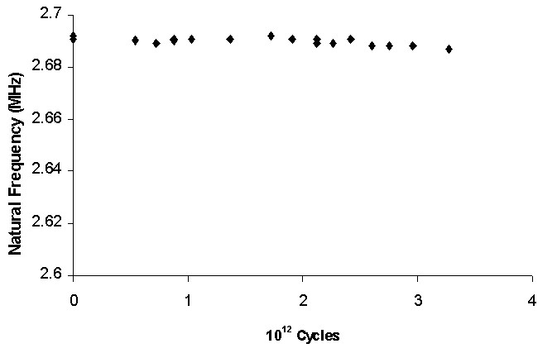Example of accelerated life testing for a single GLV device

Figure 4: Life Cycling Stability (2 MHz) (Jahja *et al.,* 2014).

The change in ribbon tension is negligible. The pixel was operated at 2 MHz – accelerated approximately 8 times over its normal 250 kHz switching rate – and 20o C, for approximately 20 days. While the test was terminated to free the test equipment for other uses, the test results give us confidence in our GLV pixel product design life of between 1013 and 1014 switching cycles. For comparison, operating at a 100 Hz frame rate with 1,920 lines for 10,000 hours requires approximately 7 x 1012 cycles (Timothy et al., 2013).

### GLV Thermal Cycling Tests

A single GLV pixel was subjected to 17 temperature cycles between 18o C and 100o C to test the thermal cycling stability of the device. Figure 5 shows the results of the test spanning a five-week period during which the pixel accumulated a total of 5 x 1011 switching cycles (David *et al.,* 2009).

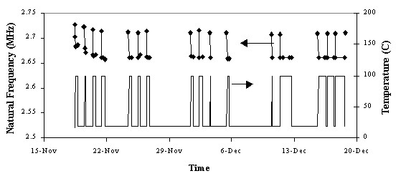

Figure 5: Thermal Cycling Stability (18-100o C) (David *et al.,* 2009).

After an initial burn-in period (the first four temperature cycles), the ribbon natural frequencies stabilized when operating at both temperature extremes. The ribbon natural frequencies decreased by ~ 2.5% as the temperature changed from 18 to 100o C because the ribbon's positive temperature coefficient resulted in less ribbon tension.

### GLV Thermal Stress Tests

Figure 6 shows GLV temperature stress data for all 1,080 pixels of a single linear test array.

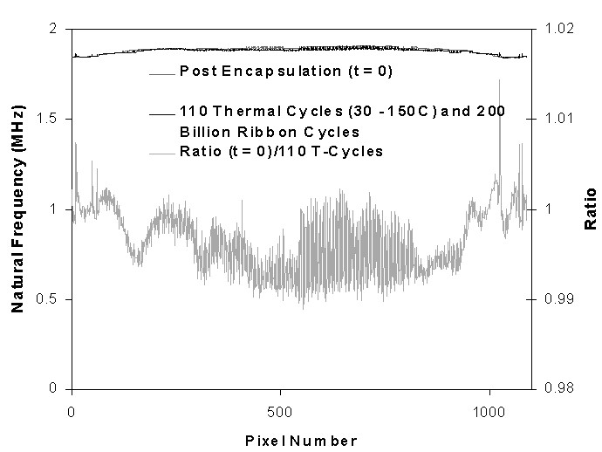

Figure 6: Thermal Stress Stability (Jahja *et al.,* 2014).

The top of the figure shows two nearly superimposed data sets. The darker-shaded data set gives the GLV ribbon resonant frequency immediately after GLV sealing and packaging, and the lighter data set gives the resonant frequency after 110 thermal cycles (30 - 150o C) and 2 x 1011 ribbon cycles – refer to the scale on the left for units. To better see how closely the data sets match (pixel-forpixel), the lowest data set plots the initial to final natural frequency ratio – refer to the scale on the right. The ratio plot shows an average pixel variation of less than ±0.5% due to temperature stress (this variation may, in fact, be due to the device, or the test, repeatability) (Jahja *et al.,* 2014).

### GLV High Optical Power Tests

To test for high optical power reliability, one GLV pixel was alternately illuminated with 1 mW and 30 mW from a 680 nm laser source over a period of days. This is roughly equivalent to illuminating a 1,080-pixel array with 1 W and 30 W, respectively. The Figure 7 test data shows both ribbon natural frequency (and thus tension) and first-order damping time under these conditions. The higher incident power causes the GLV ribbon to heat and linearly expand, thus reducing its tension and its natural frequency. The same heating causes the device fill gas to become more viscous, thus increasing the damping time. Again, after an initial burn-in cycle and a ~0.5% change, the resonant frequency and damping factor are stable over time at both low and high operating powers. Although not documented here, we have also conducted initial thermal stress and thermal cycling reliability tests down to –15o C with no observable device degradation (Jahja *et al.,* 2014).

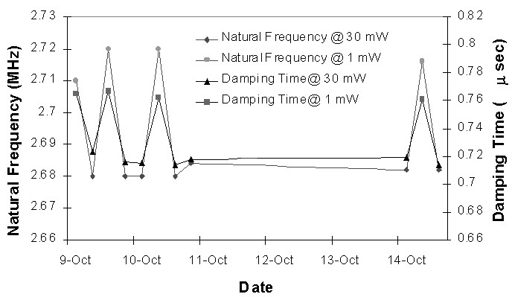

Figure 7: Stability at High Power (30 mW/pixel, 680 nm) (Jahja *et al.,* 2014).

**Conclusion**

The Grating Light Valve technology, and the Scanned GLV Architecture which it uniquely enables, together provide a solid, stable, demonstrated methodology for creating real-time, high-resolution color images in a wide variety of display applications. We have gathered a significant amount of reliability test data on a small sample of devices. Under all testing conditions – hot/cold, individual pixel/array, low/high incident flux, short/long term we have witnessed no device shut-down, no failure mode, and no device degradation. We expect our ongoing statistical reliability test plan to further demonstrate that GLV devices are rugged and dependable.

**Recommendations**

1. In order to use the bi stability of the devices for switching, it is necessary to ensure that the hysteresis loop is made as open as possible. This might be achieved by using conducting beams or beams with higher permittivity’s. Conducting beams would have the effect of decreasing the gap between the top and bottom electrodes when the beams are down.
2. This increase in capacitance would cause a substantial decrease in the first instability voltage. A second area of research is to determine the effect of surface roughness on contrast ratio. This will help determine whether roughness or striations should be used to reduce sticking. A new process for striations should be designed that is self-aligned and produces quarter micron striations.
3. Third, the devices of this paper were all produced with LPCVD. This process requires too high temperatures to be compatible with driver circuit fabrication. Either a move to PECVD or to alternate materials must be considered. Possibilities for alternate materials include spin-on glasses, polymers, metals, and other types of oxynitrides. This process redesign is absolutely necessary for reliable operation, since the high temperatures of the current process make it necessary to bond the drivers to the display rather than integrate them monolithically.

**References**

Bloom, D. (2007). The grating light valve: revolutionizing display technology", *Proc. of Photonics West Projection Displays*, 3(1), 23-44.

David, T., Amm O. & Robert, W. (2009). Optical performance of the grating light valve technology", *Photonics West-Electronic Imaging Projection Displays*, 5(1), 19-31.

Jahja, I., Trisnadi, T., Clinton, B. & Robert, M. (2014). Overview and applications of Grating Light Valve™ based optical write engines for high-speed digital imaging", *Photonics West-Micromachining and Microfabrication Symposium*, 2004.

Kenneth, G., Spears, S., Jenifer, S., Nils, H., Abramson, X., Zhu X. & Hans, J. (2017). Chrono-coherent imaging for medicine", *IEEE Transactions on Biomedical Engg*, 36(12), 11-18.

Kim, S., Barbastathis, G. & Tuller, H. (2004). MEMS for optical functionality", *Journal of Electroceramics*, 12(1), 133-144.

Perumal, S., Sankar, P. & Sundaravadivelu, S. (2013). Micro machined nonlinear wavelength filters for image acquisition", *International Journal of Imaging Science and Engg*, 2(1), 17-37.

Timothy, P., Kurzweg, F., Jose, A., Martinez, S., Steven, P., Levitan, V. Mark, K. & Donald, M. (2013). System simulation of a GLV projection system", *Proc. SPIE 4985 MOEMS Display and Imaging Systems*, 2(1), 13-21.